# Project Design Phase-I Solution Architecture

|  |  |
| --- | --- |
| Date | 11 October 2022 |
| Team ID | PNT2022TMID25106 |
| Project Name | Crude Oi Pricel Prediction |
| Maximum Marks | 4 Marks |

**Solution Architecture:**

Solution architecture is a complex process – with many sub-processes – that bridges the gap between business problems and technology solutions. Its goals are to:

* Our Project is focused mainly on the use of Neural Networks to predict Crude Oil Prices. By making this prediction, we can buy crude oil at the most sappropriate time. The most accurate way to predict future crude oil prices is to use time series analysis since we are using historical data on crude oil prices. In order to complete the task, we would implement a RNN (Recurrent Neural Network) in conjunction with a LSTM (Long Short Term Memory).

# Our Solution Architecture Diagram:

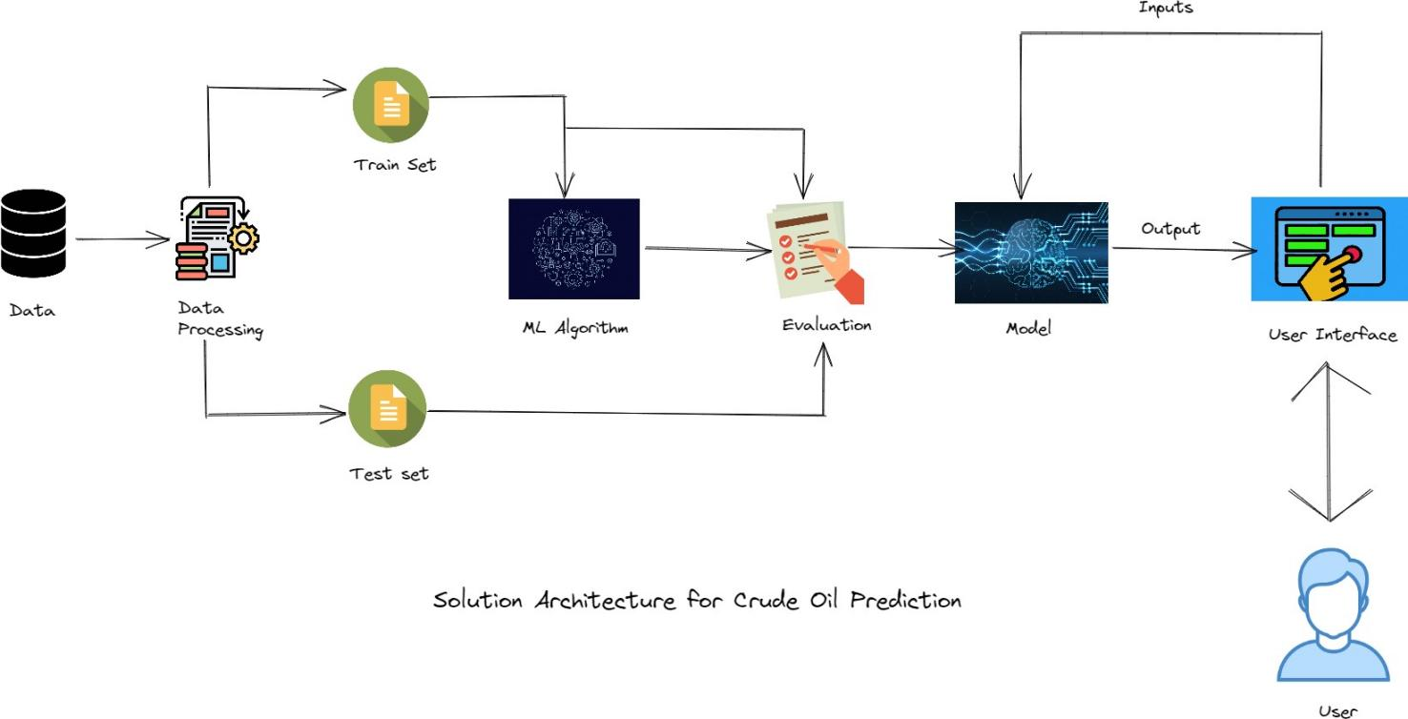

**Figure 1: Solution Architecture for crude oil prediction**